Would Wider Public Use of Facial Covering Save Livings of England During the First Wave

MSc Business Analytics

Imperial College London

August 2020

Word Count: 4646

Table of Contents

Abstract 3

Introduction 3

Model 6

Compartmental Models in epidemiology 6

Parameters of Compartmental Models 8

Default Value of Parameters 10

Adjusting Model with Consideration of Mask Use in Public 12

Projecting Death Of The First Wave Under Different Coverage 14

Result 14

Fitting the Parameters of Baseline Model 14

Predicting Death of First Wave under different scenario of Facial Coverage 17

Conclusion 18

References 19

Abstract

Covid-19, since its initial outbreak in Wuhan, China, has spread to whole world. It has dramatically affects the globalization of traveling and supply chain. Countries, such as China and Australia, are closing its border to foreigners to limit the spread of virus from outsiders. Moreover, government found it was hard to cope with the surging demand of medical equipment, such as ventilator and surgical masks, which have resulted in hundreds of thousands of death. This paper applies compartment model to analyze the relationship between facial covering’s public coverage and Covid-19 death rate and to predict how coverage of facial covering under different scenarios would impact death date in the first wave of United Kingdom. It founds that if United Kingdom have sufficient storage of facial covering so 30% of general population wear mask in public space, the death during the first wave would be halved. If 70% of general population wears mask in public space, the reported death would be less than a normal flu season. This paper hopes to provide some insights that how England’s reliance on foreign manufacturer to produce facial coverings resulted in its high death rate in the first wave and illustrate the importance of supporting domestic manufacturing capacity to cope with unexpected crisis.

Introduction

Coronavirus disease, also known as Covid-19, is an infectious disease caused by severe acute respiratory syndrome coronavirus 2, also known as SARS-CoV-2. Being a highly infectious disease, Covid-19 has spread to almost whole world since the first confirmed victim, a Wuhan resident, fell sick on Dec. 8, 2019(2). On 30 January 2020, following the fact that COVID-19 has spread from the People’s Republic of China to 20 other countries, the World Health Organization (WHO) declared the outbreak as a Public Health Emergency of International Concern(3). On 11 March 2020, WHO made the assessment that COVID-19 can be characterized as a pandemic(4). The United Kingdom became a part of the worldwide pandemic after two people from the same family have tested positive for coronavirus in England on 31 January 2020(5). The initial response from British government on the COVID-19 situation was to launch public health information campaign to minimize the impact of COVID-19 on society.

A research into SARS, the first identified strain of the coronavirus which caused the 2002–2004 SARS outbreak, proved that masks would probably provide some increased protection to the general public since SARS CoV has been suggested to be spread by aerosol droplet(18). As a result, for countries and region that had been impacted by the 2002-2004 SARS outbreak, governments recommended public use of facial covering immediately. For example, the National Health Commission of Wuhan, where the first outbreak emerged, urged public to wear mask on Dec, 12, 2020(19).

While the study on severe acute respiratory syndrome (SARS) has showed that frequent mask use in public venues were significant protective factors(8), England Government's campaign on the public use of mask was vague. On March 12, 2020, Dr Jenny Harries, the Deputy Chief Medical Officer, claimed the government's instance on the issue of face masks is that “If a healthcare professional hasn’t advised you to wear a face mask, it’s usually quite a bad idea."(17). It takes a while for the government to announce that face coverings would be mandatory on public transport after 15 June(7), and mandatory in shops and supermarkets after 24 July. [20]

While the reason for UK government not recommending public to use masks could be various, one possible explanation is that: it threats the supplies for healthcare workers[21]. As surgical masks were mainly used by medical staff and the surging demand of facial covering during the pandemic is unexpected. Early on in the pandemic, the NHS experienced severe shortages of personal protective equipment, known as PPE(6). On April 21, staff who need long-sleeved gowns were reported to not be able to access them because of national supply shortages[23].

Even for China, the top exporter of face masks(24), the supply of masks was a challenge in the beginning of pandemic. In February, 2020, medical staffs in China were reported to make their own facial covering because of the storage of masks[25]. It came as no surprise UK, the 7th largest importer of goods critical to combatting COVID-19 and 65% of it come from China [26], would have issue of PPE shortage. Moreover, the supply chain of surgical marks was heavily impacted because of the surging demand, which results protectionism all over the world. In January, 2020, Taiwan bans export of surgical, N95 masks amid China coronavirus outbreak.[27]. In March, 2020, France government forced a face mask manufacturer to cancel a major UK order(10). In 10 April 2020, British Government dispatched a RAF plane to pressure Turkey to release gowns for NHS(9). Dominic Raab, the Foreign Secretary, spoke in the 16 April 2020 daily press briefing on the government's response to the COVID-19 pandemic that the sufficient supply of PPE to meet future demand is one of the 5 specific things which the government will need to be satisfied of before adjusting any restriction[22].

In the future, whether de-globalization would emerge or whether nations will define new strategic materials is beyond the scope of this paper. This paper tends to quantify the importance of keeping sufficient storage of facial covering by predicting that whether a wider public use of facial covering in the first wave would save more life in England during the first wave.

The model to predict the impact of facial coverage upon the death must be based on the reported death and cases of pandemic in United Kingdom, which could be found UK Government Website. The daily reported cases and daily reported death of United Kingdom of the first wave and second wave are draw below.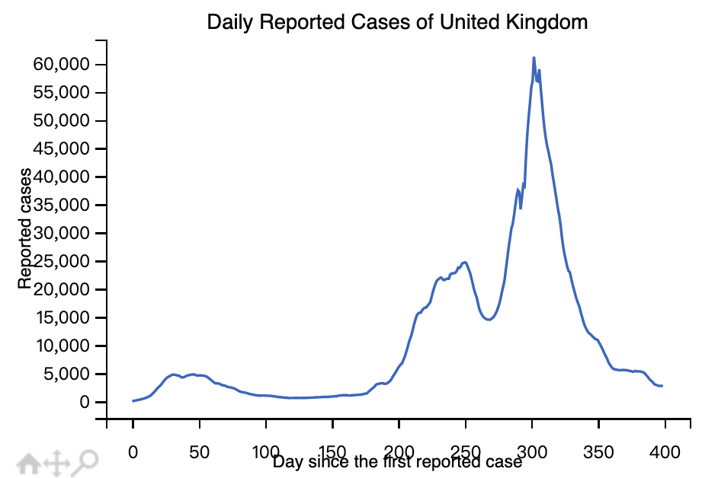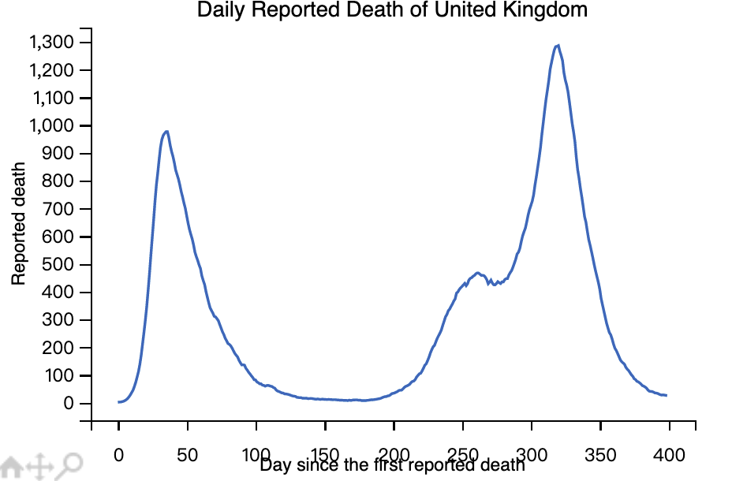

Comparing the daily reported cases and daily reported death of United Kingdom of the first and second wave, it is obvious that while the death toll curves of the first wave and the second wave of epidemics are very similar, the curve of number of reported cases is quite different. Therefore, the reason for the such discrepancy between the two plots is believed to be that is that the official reported cases is not equal to the actual number of people infected during the pandmeic. There are many reasons for this phenomenon, including asymptomatic infections, insufficient antibody testing, different official testing targets, patients subjectively refused testing for various reasons (such as not wanting to be quarantined), etc. Also, at the beginning of the outbreak in early 2020, due to the lack of testing capacity, the ratio of infected/reports is much smaller than it is now. Therefore, we need some means to estimate the true number of infections.

Model

Compartmental Models in epidemiology

Since the initial outbreak of pandemic, due to the characteristics of covid-19, the number of reported cases is believed to be far smaller than the number of actual infections. For example, Pratha estimated that more than one-third of infections are truly asymptomatic after analyzing over 350 papers. [29]. Understanding asymptomatic cases is critical for governments health responses to the pandemic, as infected people who do not show symptoms could still spread the virus. Therefore, data analysts, biologists, and mathematicians have tried to predict the official number of infections through many models. There is no doubt that no model can accurately predict the actual number of infected people, but a sophisticated model can provide very meaningful insights.

This paper uses compartmental models in epidemiology to predict whether different mask coverage would affect the number of deaths in UK during the first wave. Compartmental models, as a mathematical model widely used in the infectious disease industry, can be adjusted according to the nature of infectious diseases to predict and guide the prevention and control of infectious diseases. For the simplest compartmental models, the population are divided into three groups: ​ (Susceptible), ​ (Infectious), or ​ (Recovered). Letter ​ stands for the infected group. Letter ​ stands for group that were infected but have recovered, who would not spread virus. Letter ​ stands for group who have never been sick but are likely to catch the virus if contacting with people that are infected, who are labelled by Letter . Since this paper tends to predict the number of deaths, Letter ​ is used to label death group. In addition, the characteristics of covid-10 are more complicated. There is an incubation period, that is, patients are asymptomatic and non-infectious within a few days after catching the virus. Patients during this period are exposed to the virus but does not become actually infected until the incubation period. Therefore, we use ​ to represent this group.

Moreover, in paper *Infectious Disease Modelling: Fit Your Model to Coronavirus Data[15]*, author Henri Froese considers that while most patients with Covid-19 do not actually need to be admitted to the hospital, due to its strong transmission, when they spread on a large scale, admitted patients might run out critical medical resources. For example, in March, 2020, a leading ventilator manufacturer said that Britain faces a “massive shortage” of ventilators that will be needed to treat critically ill patients suffering from coronavirus. [16]. In order to better estimate the deaths caused by the large-scale spread of Covid-19. The author proposes an adjustment to the baseline compartmental models by labeling individuals that need intensive care with letter ​.

The six compartments of the baseline epidemiology are shown below.

| **Letters** | **Compartments** |
| --- | --- |
|  | Susceptible people |
|  | Exposed people |
|  | Infectious people |
|  | Patients need Critical Care |
|  | Recovered People |
|  | Dead People |

Parameters of Compartmental Models

Compartmental models require parameters to quantify the changing rate of different compartments. This paper applies the model that is set by Henri Froese[15].

Firstly, the chance that a susceptible individual meets infectious people is ​, and the rate of catching the virus is ​. Therefore, the changing rate of group is , as number of S decreases while more susceptible people catch the virus.

Secondly, as partial of exposed people turn to infectious people at each time unit, the rate is quantified by parameter . Moreover, is the increased exposed people at each time unit. Therefore, the changing rate of is .

Thirdly, for infected people, partial of them recover while not admitted to hospital, but others requires medical assistance(on other words, falling into crucial condition and requiring occupancy of a bed in hospital). Therefore, we assume that the probability for a patient turning to critical condition and requiring medical assistance is , and the rate of turning to critical condition is . Moreover, we assume that the probability for a patient requiring no medical assistance is , and the rate of recovering is . Finally, at each time unit, infected people increased by . Therefore, the changing rate of is .

Fourthly, we denote the probability of a patient who is in critical condition, occupies a bed in hospital since there is an available one but still unfortunately dies by . Moreover, there is three scenarios for patients who are in critical condition. In the first scenario, patient occupies a bed but unfortunately dies. The number of available bed is denoted by . Since the number of available beds is limited, the number of patients in the first scenario is . If we denote the rate of a patient dies while in critical condition by , the changing rate of patients of the first scenario is . In the second scenario, patient occupies a bed and recover. If we denote the rate of a patient recovering from critical condition by , the changing rate of patients of the second scenario is . In the third scenario, a patient is in critical condition but could not get medical assistance in hospital since there is no bed. The third scenario occurs while the number of patient who is in critical condition exceeds the number of available bed, or . If we assume that patient in the third scenario dies soon, the changing rate of patients of the third scenario is . As the rate of infected patients turning to critical condition is , the changing rate of is

Fifthly, the recovered people is consisted of who recover after catching the virus and who fall into critical condition but recover after getting medical assistance. The changing rate of patients of the first type is , and the changing rate of patients of the second type is . Therefore, the changing rate of is

Lastly, the dead people is consisted of who die because shortage of bed and who die after getting medical assistance. The changing rate of patients of the first type is , and the changing rate of patients of the second type is . Therefore, the changing rate of is

|  |  |
| --- | --- |
| **Compartment** | **Changing Rate** |
|  |  |
|  |  |
|  |  |
|  |  |
|  |  |
|  |  |
|  |  |

The table to conclude all compartment in the epidemiology model is below:

The table to conclude all parameters in the epidemiology model is below:

|  |  |
| --- | --- |
| **Parameters** | **Explanation** |
|  | Rate of susceptible people catching the virus from infected people |
|  | Rate of exposed people turning to infectious people, reverse of the incubation period |
|  | Rate of infected patient turning to critical condition |
|  | Probability for a patient turning to critical condition and requiring medical assistance |
|  | Rate of infected people recovering without medical assistance |
|  | Probability of a patient receiving medial assistance but still dies |
|  | Rate of a patient dies while in critical condition |
|  | Rate of a patient recovering from critical condition |

Default Value of Parameters

For , as it is not intuitive, we could visualize it by using reproduction number (), which is a widely used epidemiological metric used to describe the contagiousness or transmissibility of infectious agents[30]. Since in model used in this paper tends to predict the cases and death only in the first wave, we assume that the reproduction number keepings falling in the period. Therefore, we could use logistic function () to calculate the rate of susceptible people catching the virus from infected people.

The function to depict the rate of catching the virus is .

Secondly, in long-term, the chance of a patient recovering in the critical condition might improve because of invention of new treatment, but in short-term, we assume (rate of infected patient turning to critical condition), (rate of a patient dies while in critical condition) and (rate of a patient recovering from critical condition) is fixed during the first wave. There is research finding that the median time from ICU admission to death was 11 days (rate is )[31], and for people who recover from critical condition, the median ICU length of stay is 10 days(rate is ) (32). Also, it is believed that ‘second-week crash’ is time of peril for some covid-19 patients who become critical ill after infected, so the rate of infected patient turning to critical condition is assumed to be . [33]

|  |  |
| --- | --- |
| **Parameters** | **Default Values** |
|  |  |
|  |  |
|  |  |

Others necessary information is also collected from online source. For instance, the population of England is collected from the UK government website[34], and the number of availableICU beds is collected from online source [35]

Lastly, other parameters that are related to the coverage of facial masks are left to be fitted by the model.

With the above compartments and parameters setting, the baseline SEIR model has been adjusted to be aligned with the characteristics of COVID. We can estimate the parameters in the model during the first wave of pandemic in England by fitting the death data during the first wave of pandemic in England. As mentioned above, the number of report cases was affected by too many factors and only represented a part of the number of infections, but the death data published by the British government is closer to the real number of deaths caused by Covid-19. We chose the first wave of the UK pandemic because at that time the British government only suppressed the pandemic through social distancing and closure of public venues. In the second wave and the third wave, there were alpha and delta variants in the UK, and the UK was continuously vaccine the nationals. In addition, patients in the first wave of pandemic might lose their immunity gained from previous infection and became susceptible to the virus agains. The above situation would make the prediction of this infectious disease model inaccurate. Therefore, we only use the first wave of death data to estimate the change in value.

Adjusting Model with Consideration of Mask Use in Public

By fitting the reported death number of England in the first wave of the pandemic, we estimated the parameters of the model. However, to assess the influence of wide public use of facial covering upon on the death, the model need to be further adjusted to be aligned with parameters representing the coverage of facial covering used in public. With the adjusted compartmental models, we could predict that how the death of people in England during the first wave could be prevented under different scenario of using mask. Whether wearing masks or not only affect the transition from susceptible people to exposed people but not others stage. Therefore, to model the influence of wide public use of facial covering, only the changing rate of susceptible people and exposed people need modification. In the paper *to mask or not to mask modeling the potential for face mask*, the author proposed a method to adjust compartment models to cope with public use of facial covering. The author aggregating all population variables into those that typically do and do not wear masks and assumed that the masks used by public have uniform inward efficiency (i.e., primary protection against catching disease) of ​, and outward efficiency (i.e., source control/protection against transmitting disease) of ​ [11].

The adjusted compartmental model is as below:

|  |  |
| --- | --- |
| **Compartment** | **Changing Rate** |
| (Wear Mask) |  |
| (Wear Mask) |  |
| (Wear Mask) |  |
| (Wear Mask) |  |
| (Wear Mask) |  |
| (Wear Mask) |  |
| (Not Wear Mask) |  |
| (Not Wear Mask) |  |
| (Not Wear Mask) |  |
| (Not Wear Mask) |  |
| (Not Wear Mask) |  |
| (Not Wear Mask) |  |
|  |  |

Projecting Death Of The First Wave Under Different Coverage

We assume that during the first wave of the pandemic, very limited people in England used masks. Therefore, we proposed three different scenarios, of which 30%, 50%, and 70% of people used masks correctly in public. We can predict whether the changes in the number of deaths during the first wave of the pandemic in England in these three situations.

Result

Fitting the Parameters of Baseline Model

On 23 June 2020, the prime minister of United Kingdom announced the easing of lockdown restrictions[28]. Therefore, we assumed that the first wave of pandemic in United Kingdom ended on Jane, 23, 2020. Furthermore, the first death in United Kingdom was reported on March 2, 2020. Therefore, the model is used to estimate the parameters based on the reported death from March, 2, 2020 to June 23, 2020, a total of approximately 110 days.

The predicted death vs. reported death and the corresponding parameters are shown below: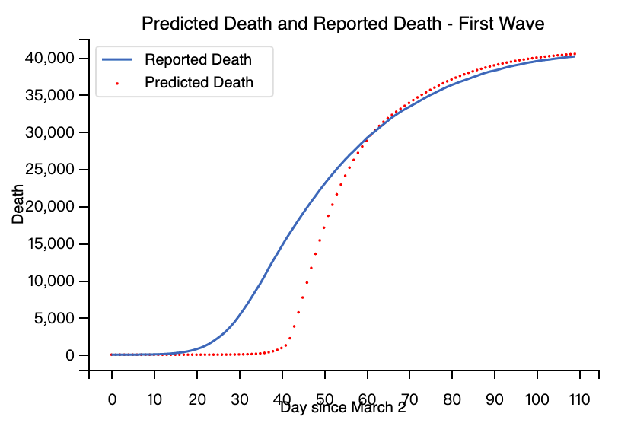

While the predicted death and reported death converge after approximately 60 days, there is discrepancy between the predicted death and reported death between 20 and 60 days. The reason could be that while the first death of United Kingdom was reported on March, 2, 2020, the covid-19 has been spreading before the date, and the first dead patient might not even be the first infected patient, as the patient had been through three stages including exposed, infected, critical ill before death. Therefore, the model needs to be adjusted to minimize error between the predicted death and reported death,

While it is possible to add an additional parameters to denote the number of days between the first infect and the first death, in paper [11], the author suggested that while this parameter is integer, integer programming is very computationally expensive[11]. Therefore, the author suggests a simplified method by filling in the reported death with zeroes at the beginning to account for the outbreak shift. As the first case of United Kingdom was reported on Jan, 30, 2020. We assume the first wave of pandemic in United Kingdom started on Jan, 30 2020 and finished on June, 23, 2020, and fill the death between Jan, 30, 2020 and March, 1, 2020 (approximately 30 days) by 0.

After adjusting the reported death, the predicted death vs. reported death and the corresponding parameters are shown below: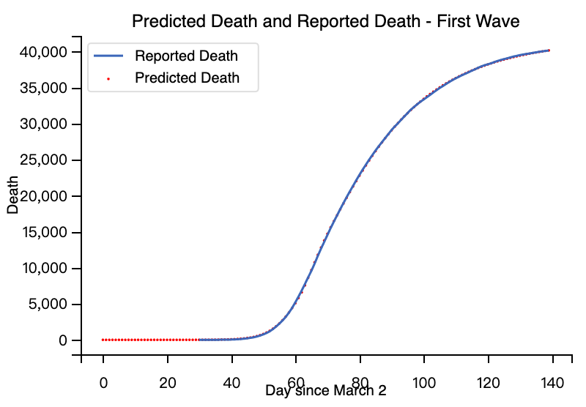

The plot in Figure 2 shows that the discrepancy between the predicted death and reported death nearly disappears after the first wave in United Kingdom is assumed to start on the first case was reported and the death between Jan, 30, 2020 and March, 1, 2020 is filled with zeros. To better verify the accuracy of the compartment model, we could predict the actual number of infected people in England between Jan, 30, 2020 and March, 1, 2020, and compare it with the cases reported by government during the period.

The predicted cases and reported cases between Jan, 30, 2020 and March, 1, 2020 is shown below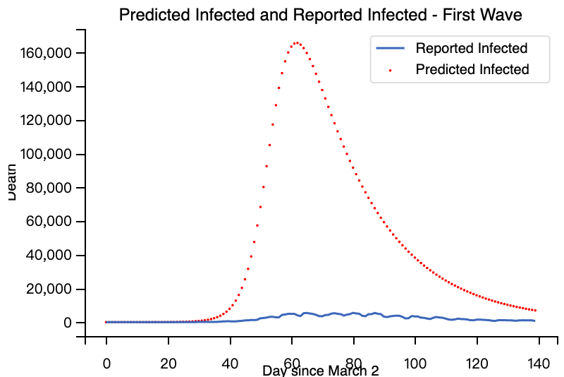

From the plot, it is obvious that the predicted number of infection far outnumber the reported number of infection during the first wave. Meanwhile, we could cumulate the fatality ratio using both the reported infection and predicted infection. Based on the prediction of the compartment model, during the first wave, the number of cumulative infections in United Kingdom is 6,219,184. Based on the data reported by UK government, the number of cumulative death during the period is 41,212, and the number of cumulative cases is 277,289. Dividing the number of cumulative death by reported number and cumulative number of infection, the reported fatality rate of UK during the first wave is 14.86%, and the predicted fatality rate of is 0.66%. The predicted fatality rate is much closer to the figure calculated by other faculties of Imperial College London, who estimate the overall COVID-19 IFR to be ranged from < 0.01% tp 2.3%, with a review combining estimates across studies reporting an overall estimate of 0.68% (0.53-0.82%)[28].

Predicting Death of First Wave under different scenario of Facial Coverage

After fitting the number of reported death to the baseline compartment model and estimating the necessary model, the SEIR model could now be used to estimate the death under different scenario of coverage of facial covering. As mentioned above, this paper assumes that very limited people in England voluntarily wear mask in public space and does not affect the spread of covid-19 in the general population. Substituting the parameters estimated via the baseline compartment model, the SEIR model generates the following plot to compare the reported death and the predicted death if 30%, 50%, or 70% wear facial covering in public space correctly.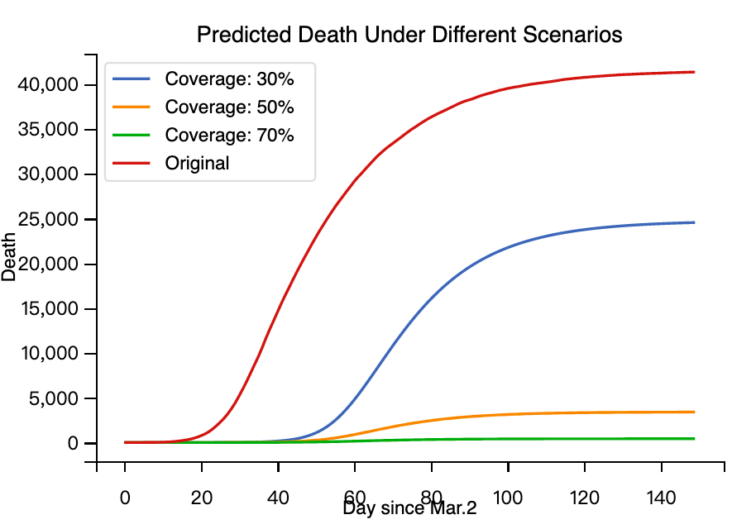

From the plots above, conclusion could be draw that even if only 30% of general population in United Kingdom wear facial covering whose efficiency is only 0.5, the number of death in United Kingdom during the first wave is largely diminished. Moreover, if 70% of the general population wear facial covering in the public space, the number of death during the first wave would be less than a normal flu season. This result seems unintuitive, but it could be supported by comparing the figure of Japan and United Kingdom. The figure from ourworldindata below shows that while the number of death in United Kingdom outnumbers most of other advanced economy, the number of death in Japan during the same period is far less than the number of United Kingdom.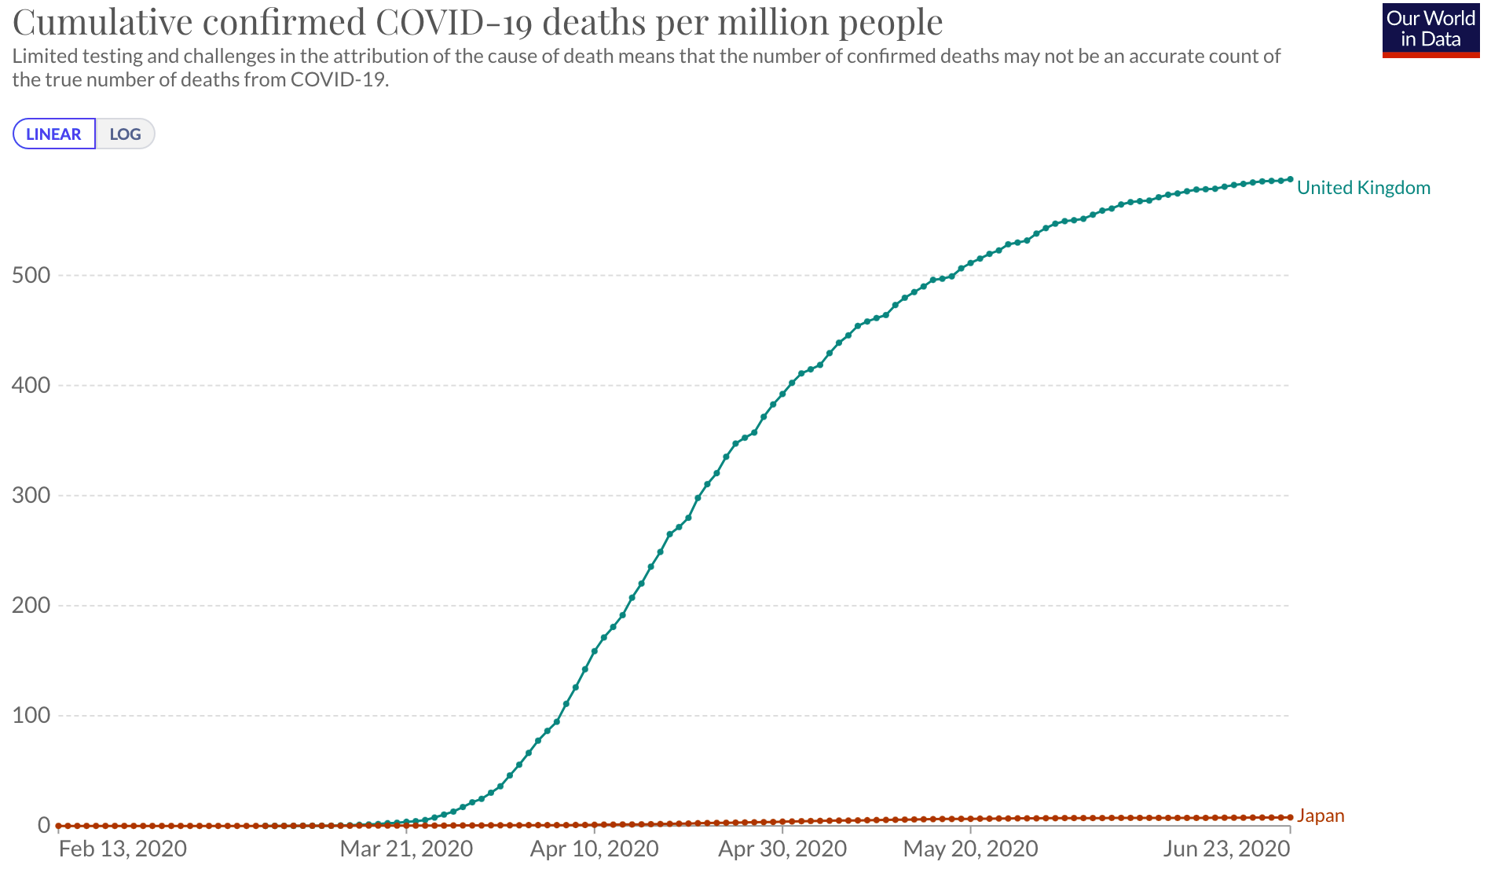

Naturally, Japan should have a larger number of death than that of United Kingdom, since Japan has a larger and older population and share closer link to China. Medical experts contribute Japan’s success in controlling the pandemic to its government’s campaign of wearing masks in public space and national’s willingness of wear masks because of previous experience of SARS outbreak in 2003.

Conclusion

In conclusion, the predicted numbers of death estimated under three scenario using the compartment model explained above indicates that the death in United Kingdom during the first wave could be larger reduced if the government could convince more people wear facial covering in the public space. However, various reasons, such as people’s hesitancy of wearing mask in public, or government’s consideration that nationals’ panic buy of mask would threat the supply of surgical masks to medical staffs, resulted in the high fatality ratio of United Kingdom comparing to other advanced economy. While the surging demand of surgical masks in unexpected in every country, countries with large capacity of manufacturing, such as China, South Korea, Japan and Taiwan, are able to cope with the unexpected surge demand of surgical masks. Using compartment model in epidemiology to prove that while the surging demand of surgical marks This paper

nd R0 cannot be modified through vaccination campaigns. R0 is rarely measured directly, and modeled R0 values are dependent on model structures and assumptions[30]

References

1. <https://www.wsj.com/articles/in-hunt-for-covid-19-origin-patient-zero-points-to-second-wuhan-market-11614335404>
2. COVID 19 PHEIC.pdf
3. <https://www.who.int/director-general/speeches/detail/who-director-general-s-opening-remarks-at-the-media-briefing-on-covid-19---11-march-2020>
4. <https://www.bbc.com/news/health-51325192>
5. <https://www.bbc.com/news/uk-54897737>
6. <https://www.independent.co.uk/news/uk/home-news/coronavirus-face-mask-uk-fine-police-public-transport-grant-shapps-tube-bus-train-a9567056.html>
7. [SARS Transmission, Risk Factors, and Prevention in Hong Kong - Volume 10, Number 4—April 2004 - Emerging Infectious Diseases journal - CDC](https://wwwnc.cdc.gov/eid/article/10/4/03-0628_article)
8. <https://www.theguardian.com/society/2020/apr/20/raf-planes-await-order-to-set-off-to-collect-ppe-from-turkey>
9. <https://www.euronews.com/2020/03/06/coronavirus-french-protective-mask-manufacturer-scraps-nhs-order-to-keep-masks-in-france>
10. To mask or not to mask: Modeling the potential for face mask use by the general public to curtail the COVID-19 pandemic
11. <https://www.webmd.com/lung/coronavirus-incubation-period#1>
12. Infectivity of asymptomatic versus symptomatic COVID-19
13. Quantifying asymptomatic infection and transmission of COVID-19 in New York City using observed cases, serology, and testing capacity
14. <https://towardsdatascience.com/infectious-disease-modelling-fit-your-model-to-coronavirus-data-2568e672dbc7>
15. <https://www.reuters.com/article/us-health-coronavirus-ventilators-idUSKBN2153JV>
16. <https://www.shropshirestar.com/news/uk-news/2020/03/11/uk-is-following-the-science-in-not-banning-mass-gatherings-health-chief/>
17. <https://jech.bmj.com/content/58/5/434.1>
18. <https://wjw.hubei.gov.cn/bmdt/dtyw/201912/t20191231_1822343.shtml>
19. <https://www.gov.uk/government/speeches/face-coverings-to-be-mandatory-in-shops-and-supermarkets-from-24-july>
20. <https://cherwell.org/2020/08/09/unmasking-the-failings-why-the-uk-government-was-too-slow-on-face-coverings/>
21. <https://www.gov.uk/government/speeches/foreign-secretarys-statement-on-coronavirus-covid-19-16-april-2020>
22. <https://www.thetimes.co.uk/article/what-steps-are-nhs-trusts-taking-when-they-run-out-of-gowns-lmxgwkg7j>
23. <https://www.maritime-executive.com/article/wto-china-is-top-exporter-of-face-masks>
24. <https://www.thepaper.cn/newsDetail_forward_5889322>
25. <https://www.wto.org/english/tratop_e/covid19_e/medical_goods_update_e.pdf>
26. <https://www.taiwannews.com.tw/en/news/3863692>
27. <https://spiral.imperial.ac.uk/bitstream/10044/1/83545/8/2020-10-29-COVID19-Report-34.pdf>
28. <https://www.pnas.org/content/118/34/e2109229118>
29. <https://wwwnc.cdc.gov/eid/article/25/1/17-1901_article>
30. <https://journals.plos.org/plosone/article?id=10.1371/journal.pone.0254550>
31. <https://www.sciencedirect.com/science/article/pii/S1201971221001235>
32. <https://www.washingtonpost.com/health/second-week-crash-is-time-of-peril-for-some-covid-19-patients/2020/04/29/3940fee2-8970-11ea-8ac1-bfb250876b7a_story.html>
33. UK Government
34. https://raw.githubusercontent.com/hf2000510/infectious_disease_modelling/master/data